Individual Dwelling Units and Heat Pump Water Heaters
2019 HPWH Building Code Assistance Sheet

Please note: For other water heating systems and configurations refer to the 2019 Building Energy Efficiency Standards section 150.2 for existing construction or 150.1 for new construction.
Related Resources:
- HPWH Code Requirements
- HPWH Permit Supplement Template
- Electrical Load Estimator.
When does the 2019 Code allow HPWHs?

 |  |  |  | Performance Path |  |  | Prescriptive Path
 | New Construction |  |  | Allowed |  |  | Allowed (detailed in HPWH Code Requirements)
 | Additions installing a 2nd water heater |  |  | Allowed |  |  | Any electric is allowed when no gas service is available
 | Alterations |  |  | Allowed |  |  | Allowed (detailed in HPWH Code Requirements)
Can a plumber (C-36 license) apply for a permit for a heat pump water heater? Yes! If:
- The HPWH does not include electrical work, OR
- The HPWH does require electrical work and the Authority Having Jurisdiction (AHJ) has a water heater permit or a joint plumbing/electrical permit, OR
- An electrical permit is required for a new panel, new circuit, etc., that permit can be applied for by a C-36 licensed contractor in a Joint Venture with an Electrical Contractor (C-10 license), by a C-10 Contractor, or by a General (B).
What is required for a HPWH on the required CF1R-ALT-05-E Compliance Form and Permit Application?
- Water Heater Type: Heat Pump Water Heater
- Fuel Type: Electric
- Heating Efficiency Type: Uniform Energy Factor (UEF)
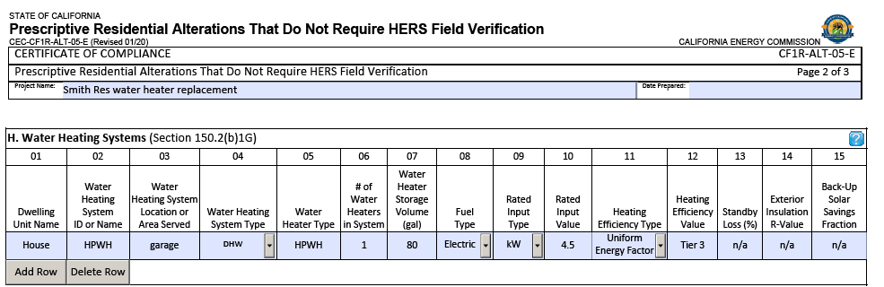
- Heating Efficiency Value: “NEEA 3” if required for a building with natural gas service; or a value ≥ the minimum UEF in accordance with federal appliance standards.
Source: www.energy.ca.gov/title24/2019standards/2019_compliance_documents/Residential_Documents/Alterations_and_Additions_Non_HERS_Verified_Forms/
What else is required to submit along with the permit?
Each jurisdiction has its own submittal requirements for a HPWH. Confirm AHJ-specific requirements with the building department. Be prepared to offer the following information during permit application or inspection:
- An electrical line/circuit diagram may be required, especially if the HPWH requires a new electric circuit, a new manual disconnect, or a new service panel.
- A site diagram may be required, especially if the HPWH is installed in a new location. Site diagrams should include the location of the water heater and demonstrate sufficient air volume and/or ventilation per manufacturer’s specifications.
- Electrical load calculations may be required, especially if the HPWH adds to the building’s electric load. If not required at permit application, have an electrical load calculation specific to the project site ready at inspection. Accepted load calculations can be developed in accordance with National Electric Code Sections 220.83b and 220.87.
- Structural load calculations may be required, especially if the HPWH is installed in a new location with raised floors, or if a HPWH with a larger tank is installed in the existing water heat location. If not required at permit submittal, have all structural load calculations required for the project ready at final inspection.

HPWH Code Requirements
2019 HPWH Building Code Requirements

BayREN and TECH Clean California offer this summary of California state level building code requirements for the installation of heat pump water heaters. This is intended to assist permit applicants and building department staff to submit, review, approve, install, and inspect heat pump water heater alterations in single family homes.
2019 HPWH Building Code Requirements
Can a HPWH replace an existing water heater and is it allowed at the site?
- The building is in CZ 1-15, natural gas is connected to the existing water heater location, and the installed HPWH is not located outdoors AND:
  - Is rated as NEEA Tier 3 (§ 150.2(b)1Hiiic) OR
  - Meets minimum federal appliance standards with demand responsive controls, and is located on an R-10 rigid surface (§ 150.2(b)1Hiiib); OR
- No natural gas is connected to the existing water heater location and the HPWH meets minimum federal appliance standards. § 150.2(b)1Hiiid OR
- The permit applicant can demonstrate the project complies with Energy Code using the performance method. § 150.2(b)2

General Water Heater Requirements
- The installed HPWH matches what is on the approved CF1R form.
- Insulation for new and existing hot and cold-water pipes from the storage tank (when accessible).
- Condensate waste removal, and if necessary, a drop/overflow basin and drainage piping. Note that condensate contains no combustion products or acids and so may be drained to sanitary sewer or to outside via a hose.
- Seismic bracing for the storage tank.

HPWH Issues Specific to Tank Size and Installation Location
- HPWH will be installed in the same location and with the same size storage tank as existing tanked water heater.
- If the HPWH has a storage tank volume greater than the existing water heater and the HPWH is installed on raised floor, a structural load calculation has been performed.
- HPWH will be installed in a location with sufficient air volume or ventilation per manufacturer’s required specifications.
- Safety bollards are present or will be installed if heat pump water heater is installed in garage in the normal path vehicle per 507.13 requirements
- If the water heater being replaced was a natural gas water heater, the natural gas line has been capped off, and gas valve removed.

Electric Circuit
- New electric circuit, conduit, manual disconnect, or visible circuit breaker will be installed that is sufficient for the HPWH.

Electric Service Panel
- Existing electric service panel is sufficient for the building’s new load with the HWPH, OR
- Electric service panel sufficient for the building’s new load will be installed, OR
- Existing electric service panel is sufficient for the building’s new load with the HPWH because a circuit pausing device or method will be used and will be connected to the dedicated HPWH circuit.

Jurisdictions May Require
- A site diagram. Applicants may use the HPWH Permit Supplement Template if AHJ deems appropriate.
- An electrical line diagram. Applicants may use the HPWH Permit Supplement Template if AHJ deems appropriate
- An electrical load calculation. Applicants may use the Electrical Load Estimator if appropriate.
- A structural load calculation, if the proposed HPWH has a storage tank greater than the existing water heater tank and will be installed on a raised floor.

Similar for CF1R-ALT-01 (altering other parts of the house) and CF1R-ADD-01 (prescriptive addition).

